複雜度重量達至100g
Complexity And Weight to 100g
我們是金屬射出成型的專家
We Are The Profession Of MIM
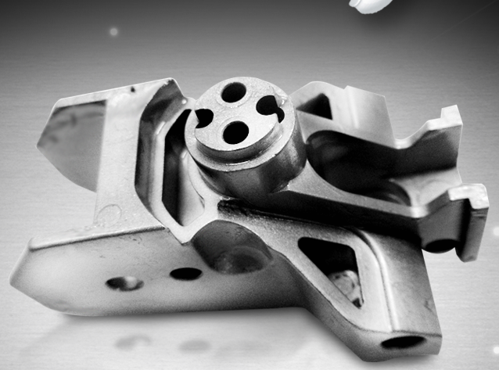

形狀自由想像設計
The Shape You Can Dream Then Design
您最值得嘗試與相信的金屬製造技術
The Worthiest Technology That You Should Trust And Try
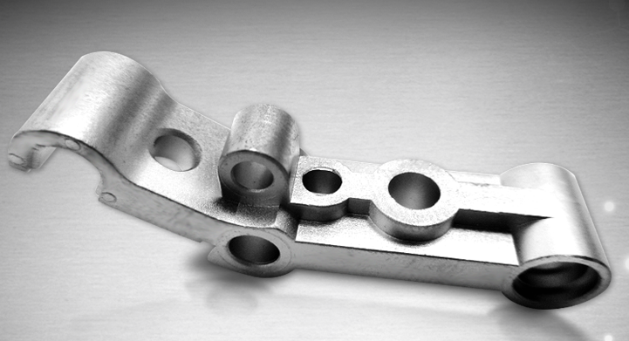

高質感表面特殊流線
The beautiful surface and special flow lines
讓您的產品成為與眾不同
Let Your Product To Be Unique
